Test Project

Web Technologies

PHP and JavaScript Module

**Submitted by:**

Sebastian Häni – CH (Independent Test Project Designer)

Cyril Wanner – CH (Independent Test Project Designer)

Patrick Zahnd – CH (Independent Test Project Designer)

# Contents

1. Contents 2
2. Introduction 3
3. Description of project and tasks 3
4. Phase one – PHP 4
   1. Database design 4
   2. Organizer interface 4
      1. Organizer login and logout 5
      2. Event management 6
      3. Ticket management 9
      4. Session management 10
      5. Channel management 12
      6. Room management 13
      7. Room capacity 14
   3. Attendee API 15
      1. Events overview 15
      2. Event detail 16
      3. Attendee login and logout 17
      4. Event registration 18
5. Phase two – JavaScript 19
   * 1. API Setup 19
     2. Introduction 20
     3. Events list 21
     4. Event agenda 22
     5. Session detail 23
     6. Event registration 24
     7. Attendee login 26
6. Notes 27
7. Submission Instructions to the Competitor 28
8. Equipment, machinery, installations, and materials required 29
9. Marking Scheme 29

# Introduction

The agency responsible for organizing the WorldSkills Conferences needs a new web application helping them to manage the events and allowing attendees to sign up and see all information they need. It should be dynamically built so that it can later be shared with other member organizations which means that multitenancy is an important requirement.

Because this application will grow over time, important requirements are covered by automated tests.

# Description of project and tasks

The project is split into two phases:

* phase one (morning, 3 hrs) for building the backend parts (admin interface and REST-API) using PHP (framework) and database
* phase two (afternoon, 3 hrs) for building the frontend parts (attendee interface) using HTML/CSS/JS (framework) and the REST-API provided for phase two.

# Phase one – PHP

## Database design

* Use your database (dbYY_competitor_day2) and import the schema/dump provided
* Extend your database to be able to store (do not modify/extend any existing table except if it is specifically noted as they will be resetted before every test run)
  + Event ratings
    - Attendees should be able to comment and rate events they have attended
    - Rating should be a full number between 1 and 5, where 1 is the lowest and 5 the highest rating
    - The date and time of the rating should be registered
  + Session ratings
    - Additional to the event rating, attendees should be able to rate sessions they have attended
    - Rating should be a full number between 1 and 5, where 1 is the lowest and 5 the highest rating
    - The date and time of the rating should be registered
* Your additional tables need to follow the third normal form.

## Organizer interface

Create an organizer interface (Server Side Rendered using a PHP Framework) using the templates provided to

* manage events, sessions, channels, rooms and tickets (create, read, update)
* create a bar chart to see the occupancy rates of all rooms
* create dynamic ticket prices
* support multiple tenants

Because different organizers will use this backend, keep security in mind. It should not be possible to access events of other organizers or update events of other organizers.

### Organizer login and logout

Because registering as a new organizer is not within the scope of this project, please update the first two organizers in the provided dump so that it is possible to log in with the following credentials:

* Email: demo1@worldskills.org Password: demopass1
* Email: demo2@worldskills.org Password: demopass2

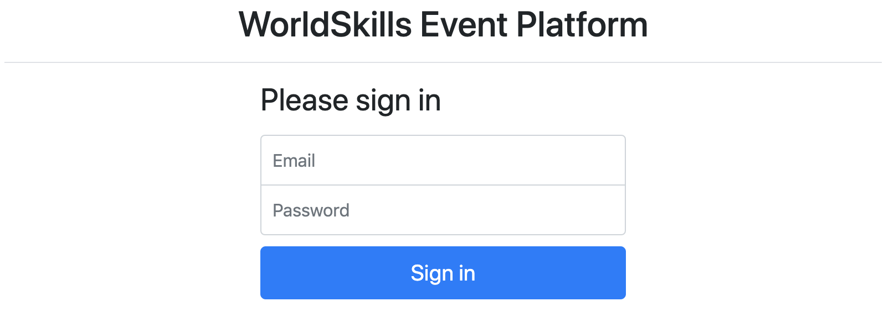

**Specification:**

*Feature:* A1 – Log in and log out as an organizer: As an organizer, I would like to log in and log out to the event platform so that I can access the functionality of the platform.

*Scenario:* A1a - Organizer login ok

*Given* I am on the "login" page

*When* I enter the specified email and password for an organizer

*And* press the "Sign in" button

*Then* I am forwarded to the organizer area

*And* organizator name and "Sign out" button become visible in the header

*And* page "Manage events" becomes visible

*Scenario:* A1b - Organizer login fail

*Given* I am on the "login" page

*When* I enter a wrong email and password combination for an organizer

or use login information of an attendee instead of an organizer

*And* press the "Sign in" button

*Then* I stay on the "login" page

*And* I see an error message "Email or password not correct"

*Scenario:* A1c - Organizer logout

*Given* I am logged in

*When* I press the "Sign out" button

*Then* I am forwarded to the "login" page

*And* organizator name and logout button and admin functions disappear

*And* I cannot reach the previous page by going back

### Event management

Organizers should be able to save all information about an event and its sessions in the database. Every organizer account can only see and edit its own events. The organizer may have zero or many events.

**Specification:**

*Feature:* A2 - Manage events: As an organizer I want to manage events so attendees can find events

*Scenario:* A2a – List all events

*Given* I am logged in

*And* I am on the "Manage events" page

*Then* I see a list of all events created by the current organizer sorted

ascendingly by their date

*And* I see the total number of registrations for every event

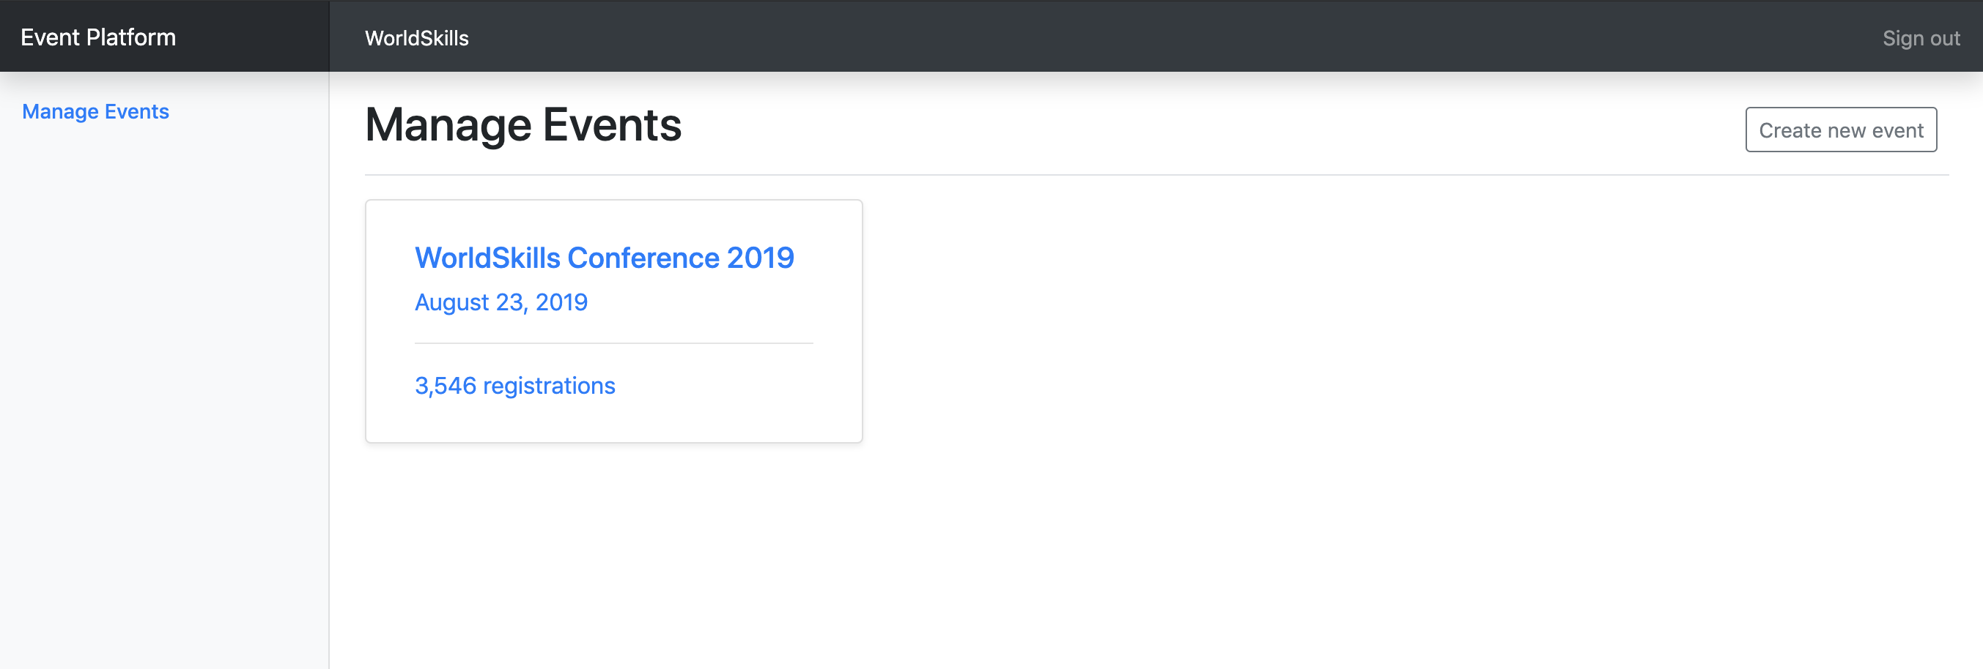

*Scenario:* A2b - Show form for new event

*Given* I am logged in

*And* I am on the "Manage events" page

*When* I press "Create new event"

*Then* a form to enter event information appears

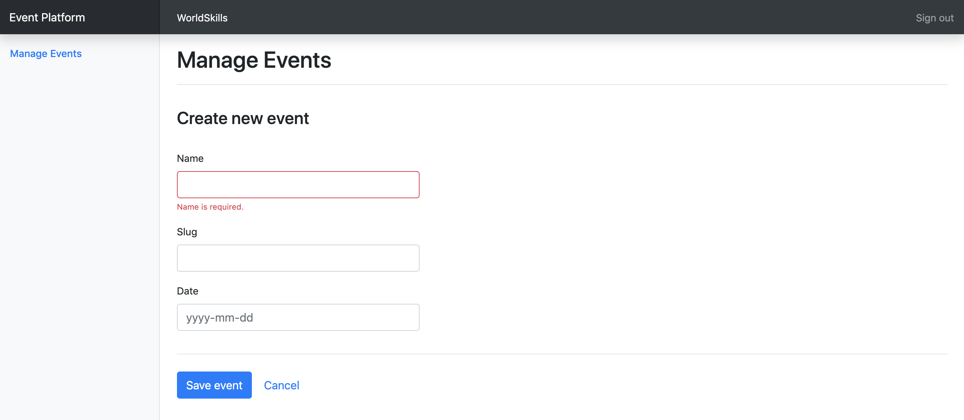

*Scenario:* A2c - Enter information for a new event

*Given* a form to enter event information is shown

*When* I enter info for the event (all fields required)

*And* I press "Save event"

*Then* the event is saved into the database

*And* I am redirected to the detail page for the newly created event

*And* a success message "Event successfully created" is shown

*Scenario:* A2d – Enter already used slug for a new event

*Given* a form to enter event information is shown

*When* I enter info for the event and use a slug which is already used by

another event of the same organizer

*And* I press "Save event"

*Then* the event is not saved into the database

*And* an error message "Slug is already used" is shown

*And* my previously submitted input data is not lost

*Scenario:* A2e – Enter invalid slug for an event

*Given* a form to enter event information is shown

*When* I enter an invalid slug for the event

*And* I press "Save event"

*Then* the event is not saved into the database

*And* an error message "Slug must not be empty and only contain a-z, 0-9 and

'-'" is shown

*Scenario:* A2f - Show form for updating event

*Given* I am logged in

*And* I am on the detail page of an event

*When* I press "Edit event"

*Then* a form to update event information appears

*Scenario:* A2g – Update event information

*Given* a form to update information of an existing event

*When* I change the prefilled old event information to new values

*And* I press "Save event"

*Then* the updated event is saved into the database

*And* I am redirected to the detail page for the updated event

*And* a success message "Event successfully updated" is shown

*Scenario:* A2h – Show event detail

*Given* I am on the "Manage events" page

*And* I click on an event in the list

*Then* I am forwarded to the detail page on this event

*And* can see all basic information as well as all relations to the available

rooms, channels, sessions and tickets



### Ticket management

For each event, organizers want to create different ticket types. Tickets can have, but don’t need, one validity rule which can be one of:

* only purchasable until a given date (e.g. book before July 30, 2019 for an early bird ticket)
* only a defined amount of tickets is available (e.g. max 50 VIP tickets)

Please check existing records in the provided dump to see how validity rules should be stored.

**Specification:**

*Feature:* A3 – Manage tickets: As an organizer I want to manage tickets that attendees can buy in the frontend

*Scenario:* A3a – Show form for new ticket

*Given* I am on the detail page of an event

*And* I press "Create new ticket"

*Then* a form to enter ticket information appears

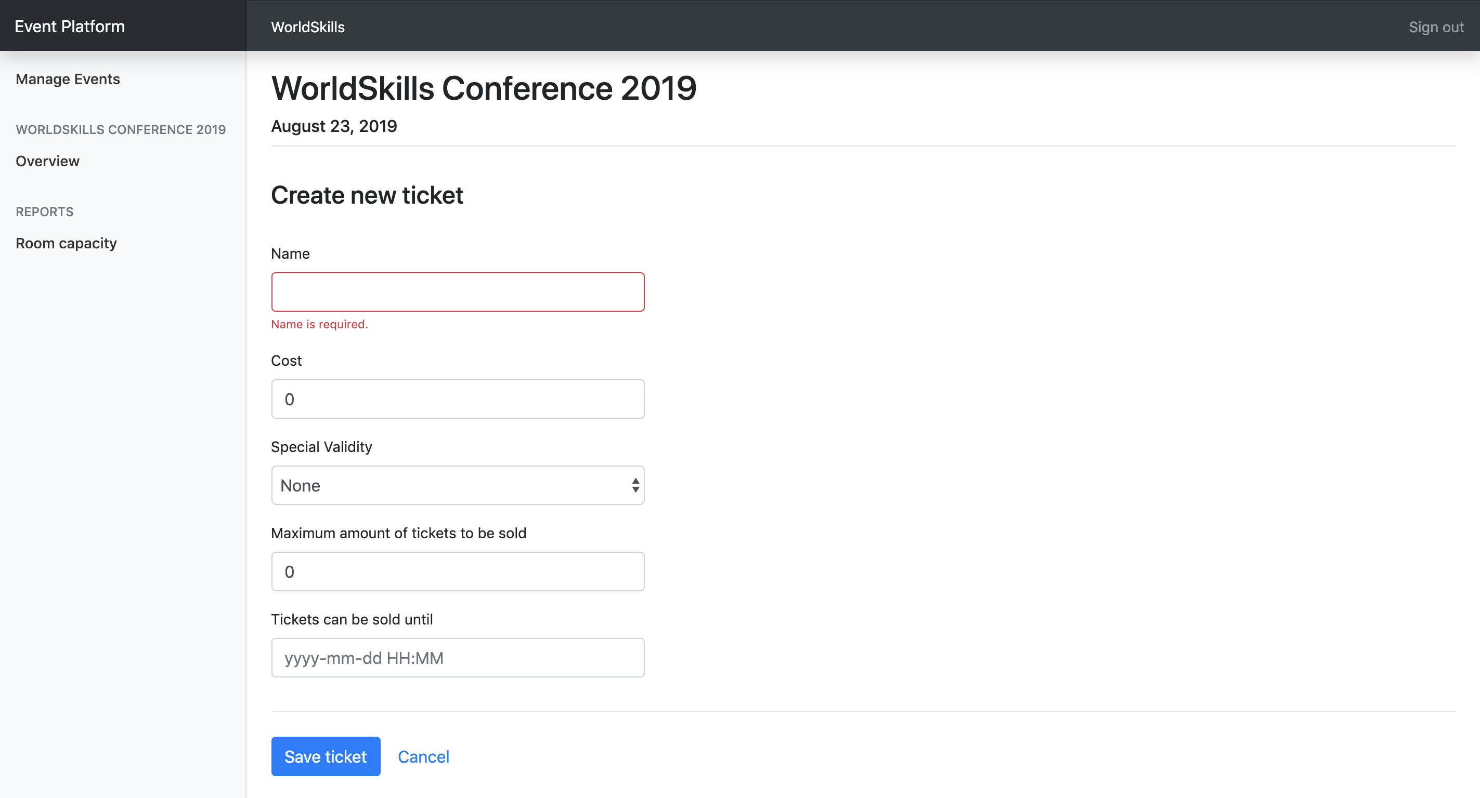

*Scenario:* A3b – Enter information for a new ticket

*Given* a form to enter session information is shown

*When* I enter information for the ticket (name and cost field are required, also any field that is related to the selected special validity rule)

*And* I press "Save ticket"

*Then* the ticket is saved into the database

*And* I am redirected to the detail page of the event it is assigned to

*And* a success message "Ticket successfully created" is shown

### Session management

For every event, organizers want to be able to list the current sessions and have the possibility to create new ones. Sessions are always assigned to a room which can not have another session during that time. Sessions are one of these two types:

* talk: A speaker presents a talk. Talks are included in the conference ticket and do not cost extra.
* workshop: A speaker holds a hand-on workshop with its attendees. Workshops can cost extra.

**Specification:**

*Feature:* A4 – Manage sessions: As an organizer I want to manage sessions that attendees can sign up for

*Scenario:* A4a – Show form for new session

*Given* I am on the detail page of an event

*And* I press "Create new session"

*Then* a form to enter session information appears



*Scenario:* A4b – Enter information for a new session

*Given* a form to enter session information is shown

*When* I enter information for the session (all fields, except cost, required)

*And* I press "Save session"

*Then* the session is saved into the database

*And* I am redirected to the detail page of the event it is assigned to

*And* a success message "Session successfully created" is shown

*Scenario:* A4c – Enter invalid information for a new session – room booked

*Given* a form to enter session information is shown

*When* I choose a room which already has another session at the same time

*And* I press "save session"

*Then* the session is not saved into the database

*And* an error message "Room already booked during this time" is shown

*And* my previously submitted input data is not lost

*Scenario:* A4d – Show form for updating session

*Given* I am on the detail page of an event

*And* I click on the name of a session

*Then* a form to update session information appears

*Scenario:* A4e – Update session information

*Given* a form to update information of an existing session

*When* I change the prefilled old event information to new values

*And* I press "Save session"

*Then* the updated session is saved into the database

*And* I am redirected to the detail page of the event it is assigned to

*And* a success message "Session successfully updated" is shown

### Channel management

A channel is used to group multiple sessions by a topic, for example management or user experience. Channels are assigned to exactly one event.

**Specification:**

*Feature:* A5 - Manage channels: As an organizer I want to manage channels of an event so sessions can get assigned to them

*Scenario:* A5a – Show form for new channel

*Given* I am on the detail page of an event

*And* I press "Create new channel"

*Then* a form to enter channel information appears

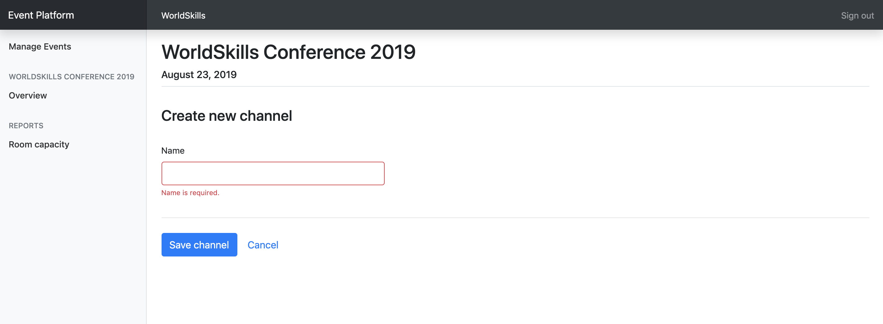

*Scenario:* A5b – Enter information for a new channel

*Given* a form to enter channel information is shown

*When* I enter information for the channel (all fields required)

*And* I press "Save channel"

*Then* the channel is saved into the database

*And* I am redirected to the detail page of the event it is assigned to

*And* a success message "Channel successfully created" is shown

### Room management

A room is assigned to exactly one channel and can have exactly one session at a time.

**Specification:**

*Feature:* A6 – Manage rooms: As an organizer I want to manage rooms which I can later assign to sessions

*Scenario:* A6a – Show form for new room

*Given* I am on the detail page of an event

*And* I press "Create new room"

*Then* a form to enter room information appears

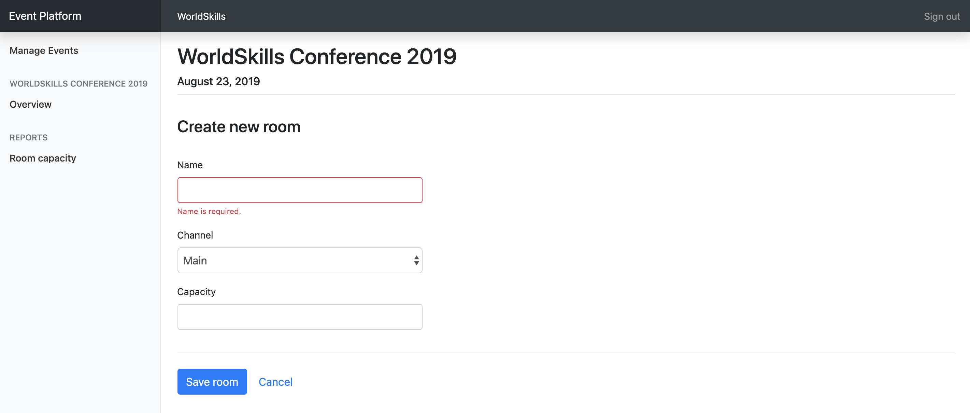

*Scenario:* A6b – Enter information for a new room

*Given* a form to enter room information is shown

*When* I enter information for the room (all fields required)

*And* I press "Save room"

*Then* the room is saved into the database

*And* I am redirected to the detail page of the event it is assigned to

*And* a success message "Room successfully created" is shown

### Room capacity

Organizers want to see an overview of all sessions with information about the room capacity and number of attendees. With this information, they can see if a room is reaching its full capacity.

Please note that for all sessions of type talk, attendees don't need a separate ticket. For sessions of type workshop, they need a separate ticket.

**Specification:**

*Feature:* A7 – Room overview: As an organizer I want to see an overview of the sessions with the room capacity and number of attendees

*Scenario:* A7a – Show room overview

*Given* I am on the detail page of an event

*When* I press the link "Room capacity" in the sidebar

*Then* I see a bar chart displaying sessions along the horizontal axis,

while the y-axis is showing the room capacity superimposed with the

registered amount of attendees

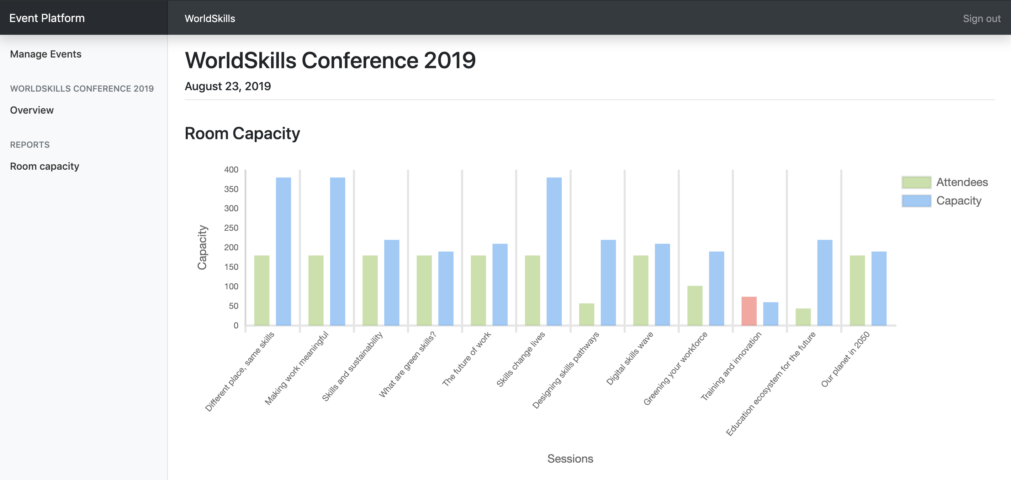

*Scenario:* A7b – Room capacity exceeded

*Given* I am on the "Room capacity" page

*When* I have a room which exceeds its capacity

*Then* I see the visitors bar highlighted with a red color instead of green

## Attendee API

Create a RESTful API (http://<hostname>/XX_JS-PHP_A/api/v1/…) to

* login and logout as an attendee
* read all upcoming events
* see the agenda for an event
* sign up and purchase a ticket for an event

### PHPUnit tests

Tests for the PHP API are distributed with the mediafiles. Please see the following instructions to set them up and configure on your own server.

**Setup:**

1. Upload the API tests to your server
2. Configure the .env file of the API tests and provide correct database credentials and the URL where your API is available.

**Running the tests:**

Execute the following command on the server inside the directory of the api tests:

|  |
| --- |
| composer test |

To only run a single test, you can use the following command for example:

|  |
| --- |
| composer test -- --filter B2EventDetailTest |

*Additional information for the REST-API tests/specification*: the body contains some static example data, adjust it to fit the requirements. Placeholder parameters in the URL are marked with curly braces: {slug}

The tests are referenced by its function name *[-> test<scenario-id><text>]*.

The order of properties in objects does not matter, but the order of items in an array does.

### Events overview

When an attendee lands on the index page of the application, he will get a list with all upcoming events across all organizers. Events should be ordered ascendilgly by their date.

**Specification:**

*Feature:* B1 – Read events: As a visitor I want to read the public data of all upcoming events so that I candisplay them in a list

*Scenario:* B1a – Read all upcoming events

Request

URL: /api/v1/events

Method: GET

Header:

Body: -

Response

If success [-> testB1aGetEvents]

Header: Response code: 200

Body: {"events": [{"id": 1, "name": "someText", "slug": "some-text", "date": "2019-08-15", "organizer": {"id": 1, "name": "someText", "slug": "some-text"}}]}

### Event detail

When an event is selected, all information of the selected event should be returned in the same endpoint.

If a session has no cost or a ticket no description, NULL will be used.

The description of a ticket is generated as following:

* NULL if no special validity rule set
* "Available until {month} {day}, {year}" if special validity rule "date" is used  
  (example: "Available until September 1, 2019")
* "X tickets available" if special validity rule "amount" is used  
  (example: "30 tickets available" where 30 is the total amount of tickets and not the remaining ones)

**Specification:**

*Feature:* B2 - Read event: As a visitor I want to read all information about an event

*Scenario:* B2a – Read all detail information of a single event

Request

URL: /api/v1/organizers/{organizer-slug}/events/{event-slug}

Method: GET

Header:

Body: -

Response

If success *[-> testB2aGetEventDetail | testB2aTicketValidity]*

Header: Response code: 200

Body: {"id": 1, "name": "someText", "slug": "some-text", "date": "2019-08-15", "channels": [{"id": 1, "name": "someText", "rooms": [{"id": 1, "name": "someText", "sessions": [{"id": 1, "title": "someText", "description": "someText", "speaker": "someText", "start": "2019-08-15 10:00:00", "end": "2019-08-15 10:45:00", "type": "workshop", "cost": 50|null}]}]}], "tickets": [{"id": 1, "name": "someText", "description": "Available until July 7, 2019"|null, "cost": 199.99, "available": true}]}

If event does not exist or was not created by the organizer *[-> testB2aGetInvalidEvent]*

Header: Response code: 404

Body: {"message": "Event not found"}

If organizer does not exist *[-> testB2aGetInvalidOrganizer]*

Header: Response code: 404

Body: {"message": "Organizer not found"}

### Attendee login and logout

After signup (which is not within the scope of this project), attendees get assigned a random 6 characters long registration code which they need when entering an event. To avoid requiring yet another password, this registration code is also used for logging the user in on the website, together with his lastname as his login credentials. The registration code is shared across all events and is *not* only valid for a single event.

For testing purposes, the registration code and last name can be seen in the database dump.

On a successful login, data of the loggedin attendee gets returned together with a token which can be sumitted with subsequent requests. For simplicity, the token is the username md5-hashed and is valid until the logout endpoint is called.

**Specification:**

*Feature:* B3 - Login and Logout as atteendee: As a visitor I want to login/logout so that I can attend an event and see my registrations

*Scenario:* B3a - Attendee login

Request

URL: /api/v1/login

Method: POST

Header:

Body: {"lastname": "someText", "registration_code": "someText"}

Response

If success *[-> testB3aCorrectLogin|SameLastname|SameRegistrationCode]*

Header: Response code: 200

Body: {"firstname: "someText", "lastname": "someText", "username": "someText", "email": "someText", "token": "AUTHORIZATION_TOKEN"} (md5 hashed username, valid until logout)

If user login info not correct *[-> testB3aInvalidLastname|RegistrationCode|Request]*

Header: Response code: 401

Body: {"message": "Invalid login"}

*Scenario:* B3b – Attendee logout

Request

URL: /api/v1/logout?token={AUTHORIZATION_TOKEN}

Method: POST

Header:

Body: -

Response

If success *[-> testB3bLogout]*

Header: Response code: 200

Body: {"message": "Logout success"}

If invalid token *[-> testB3bInvalidToken | testB3bAlreadyLoggedOut]*

Header: Response code: 401

Body: {"message": "Invalid token"}

### Event registration

Users will register and buy a ticket with this endpoint. The different ticket validity rules (date or amount) should be validated. Registrations should be sorted ascendingly by their id.

**Specification:**

*Feature:* B4 – Event registration: As a visitor I want to register for an event

*Scenario:* B4a – New event registration

Request

URL: /api/v1/organizers/{organizer-slug}/events/{event-slug}/registration?token={AUTHORIZATION_TOKEN}

Method: POST

Header:

Body: {"ticket_id": 1, "session_ids": [1, 2, 3]} (session_ids is optional)

Response

If success *[-> testB4aCorrectRegistration]*

Header: Response code: 200

Body: {"message": "Registration successful"}

If user is not logged in or token is invalid *[-> testB4aLoggedOut]*

Header: Response code: 401

Body: {"message": "User not logged in"}

If user already registered for this event *[-> testB4aAlreadyRegistered]*

Header: Response code: 401

Body: {"message": "User already registered"}

If ticket is not available anymore *[-> testB4aInvalidTicket]*

Header: Response code: 401

Body: {"message": "Ticket is no longer available"}

*Scenario:* B4b – Get registrations of a user

Request

URL: /api/v1/registrations?token={AUTHORIZATION_TOKEN}

Method: GET

Header:

Body: -

Response

If success *[-> testB4bGetRegistrations | testB4bNewRegistration]*

Header: Response code: 200

Body: {"registrations": [{"event": {"id": 1, "name": "someText", "slug": "some-text", "date": "2019-08-15", "organizer": {"id": 1, "name": "someText", "slug": "some-text"}}, "session_ids": [1, 2, 3]}]}

If user is not logged in or token is invalid *[-> testB4bLoggedOut]*

Header: Response code: 401

Body: {"message": "User not logged in"}

# Phase two – JavaScript

### API Setup

The API needed for this part will be **provided after lunch** and can be set up with the following instructions. In case you want to start with part two before lunch, you have to use your own API from part one.

**Automated setup:**

Connect to your server through SSH and execute the following command (in your home directory):

|  |
| --- |
| setup-api |

This will automatically set up the API and database on your server. After completion, the API is available at <http://XX.skill17.com/day2-afternoon>/ (XX is your workstation number).

The API is implemented according to the specification of the Attendees API in part one.

**Manual setup:**

The manual setup should only be done in case the automatic setup fails.

1. Download the API from <http://wsi.skill17.com/day2_afternoon_api.zip> (only available in the afternoon)
2. Upload it to your server and unzip it into the folder /home/competitor/www/day2-afternoon (ensure that the unzipped files files are directly located in the folder /home/competitor/www/day2-afternoon and not in another subfolder)
3. Create a new database called day2_afternoon and import the provided dump from part one
4. The API is now available at <http://XX.skill17.com/day2-afternoon>/ (XX is your workstation number)

### Introduction

Using the RESTful API (all data coming/going into database), create a frontend for attendees to browse information about the events, login/logout and register for an event. During registration, it should be possible to add additional workshops they want to attend.

The RESTful API supports POST requests with JSON or FormData bodies, but the correct request headers need to be set accordingly to the used body type.

Interaction should show error/feedback messages based on response from the API where appropriate. Also, an error page should be shown when accessing an invalid URL.

Browsing all data is public and no user is required. But as soon as they want to register for an event, they need to be signed in.

Refreshing a page should always display the same page and it must be possible to share a page by URL so that all state is kept in the URL.

The layout should follow mockups exactly. The position of elemenst in design should be same as mockups.

The yellow bubbles in the mockups show classes and ids which have to be used for those elements to allow running automated tests. The yellow bubbles are not part of the design and do not have to be displayed in the browser.

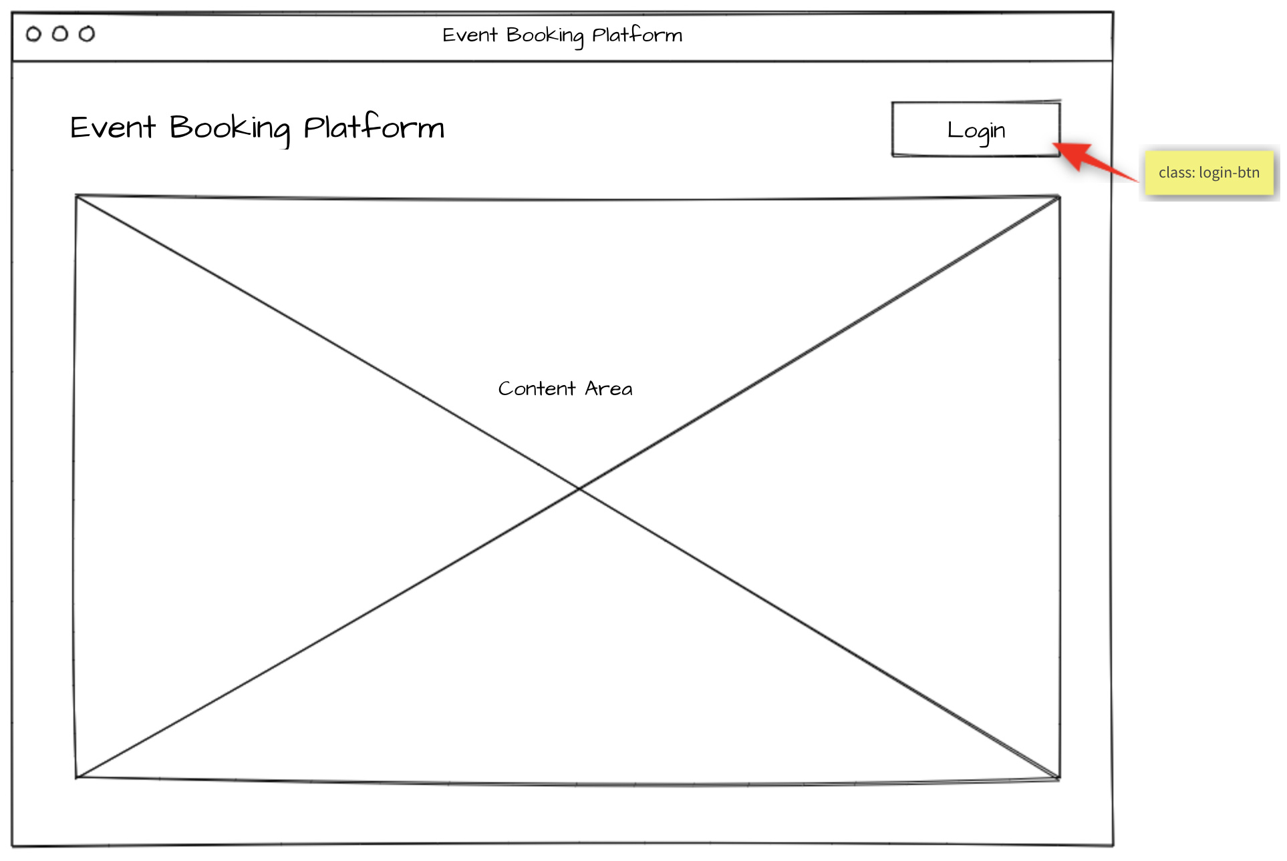

### Events list

When accessing the index page, all upcoming events are displayed with their organizer name and the date it takes place. By selecting an event, the event agenda will be shown.

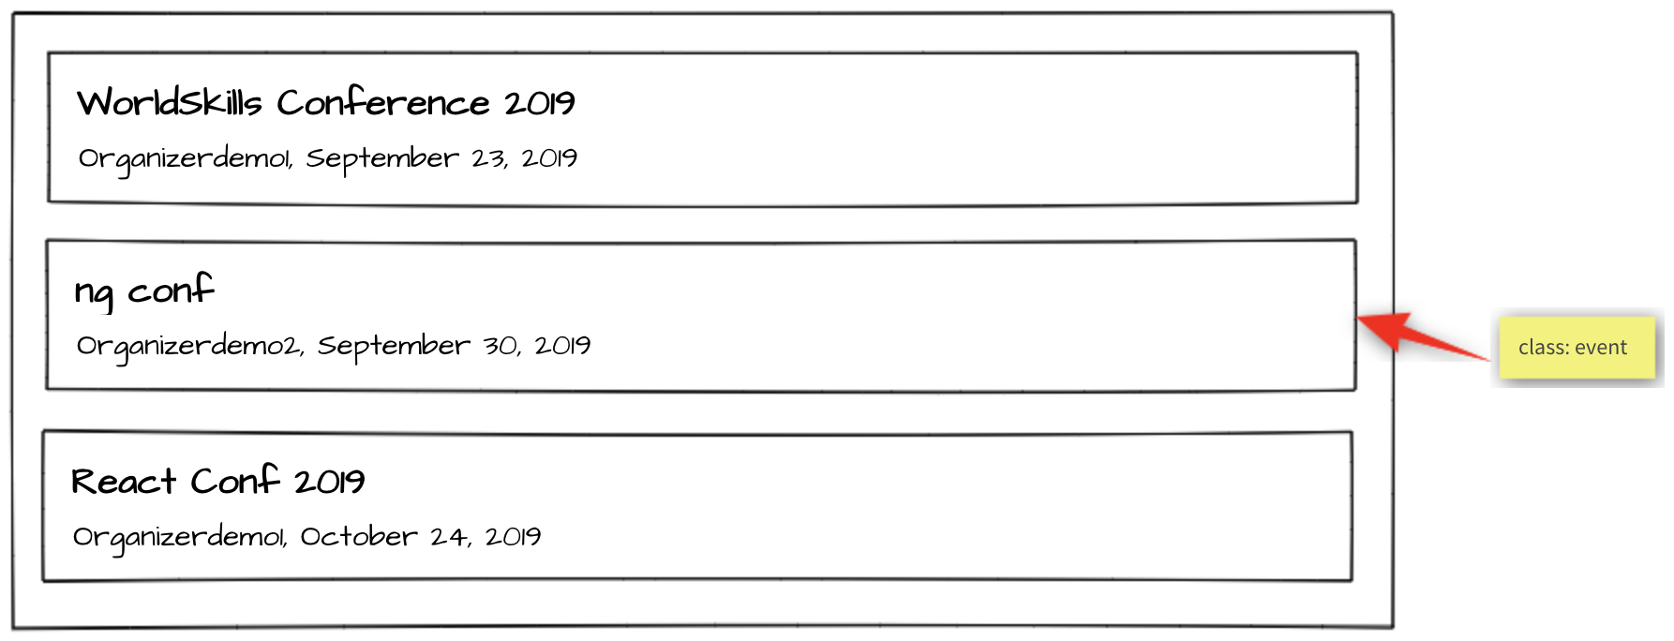

**Specification:**

*Feature* C1 - List upcoming events: As an attendee, I want to see what events I can attend.

*Scenario*: C1a - List upcoming events

*Given* I am on the home page

*Then* I see a chronologically ordered list of upcoming events across all

organizers

*And* I can click on an event

### Event agenda

The agenda of the selected event is shown. If the user is logged in and is already registered for this event, all sessions with type talk are highlighted with a green border since they are automatically included in every event registration. Additionally, if the user signed up for addition sessions of type workshop, they will also be highlighted with a green border.

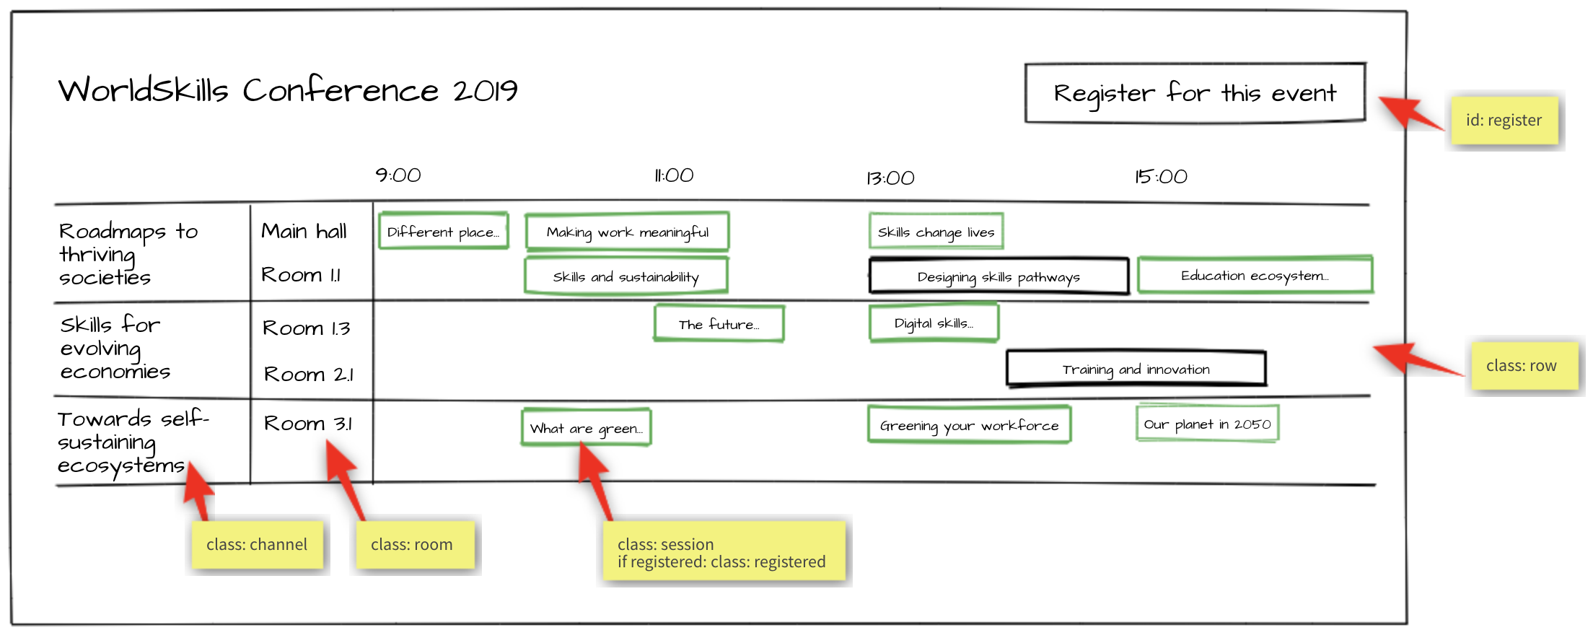

**Specification:**

*Feature* C2 - Display event agenda: As an attendee, I want to see what sessions are within an event.

*Scenario*: C2a - Display channels

*Given* I am on an event detail page

*Then* I see the channels of the event forming horizontal swimlanes

*And* the channels contain the rooms as "inside"-swimlanes

*Scenario*: C2b - Display talk and workshop sessions

*Given* I am on an event detail page

*Then* I see the timeline containing "9:00", "11:00", "13:00", "15:00"

*And* I see the sessions in the correct room swimlane starting and ending

at the correct time

*Scenario*: C2c - Display registered sessions

*Given* I am on an event detail page

*And* I am logged in

*And* I am already registered for this event

*Then* I see all sessions of type talk highlighted with a green border

*And* I see all sessions of type workshop which I have signed up for

highlighted with a green border

### Session detail

When clicking on a session within the agenda, a detail page showing all information about this session will be shown.

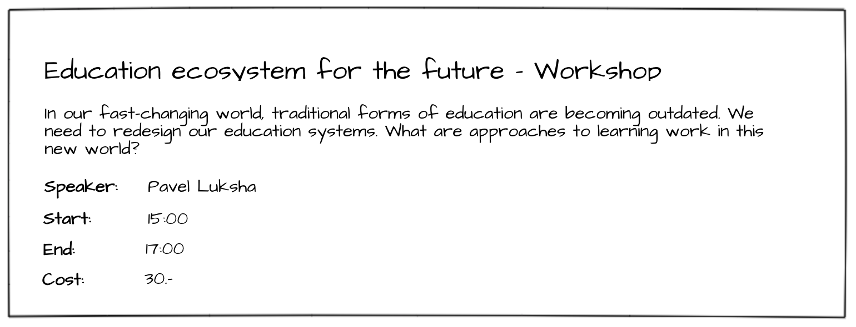

**Specification:**

*Feature* C3 - Display session details: As an attendee, I want to inform myself about the details of a session.

*Scenario*: C3a - Display session details

*Given* I am on an event detail page

*When* I click on a session

*Then* I see a detail page of the session containing title, description,

speaker, start and end time, type and the cost (if it is set)

### Event registration

After clicking on "register for this event", the user either sees the event registration form if he is logged in or gets redirected to the login form if he is not logged in.

On the event registration form, he can select the ticket type he wants. Unavailable tickets are greyed out and can't be selected. The API is responsible for this information and the validation, so it does not have to be handled in the frontend.

The user can also select additional sessions of type workshop he wants to attend. If a session has an additional cost, it will show up in the cost view and add to the total cost.

After clicking on "Purchase", the user will be registered for this event and the sessions he has selected and gets redirected back to the event detail page.

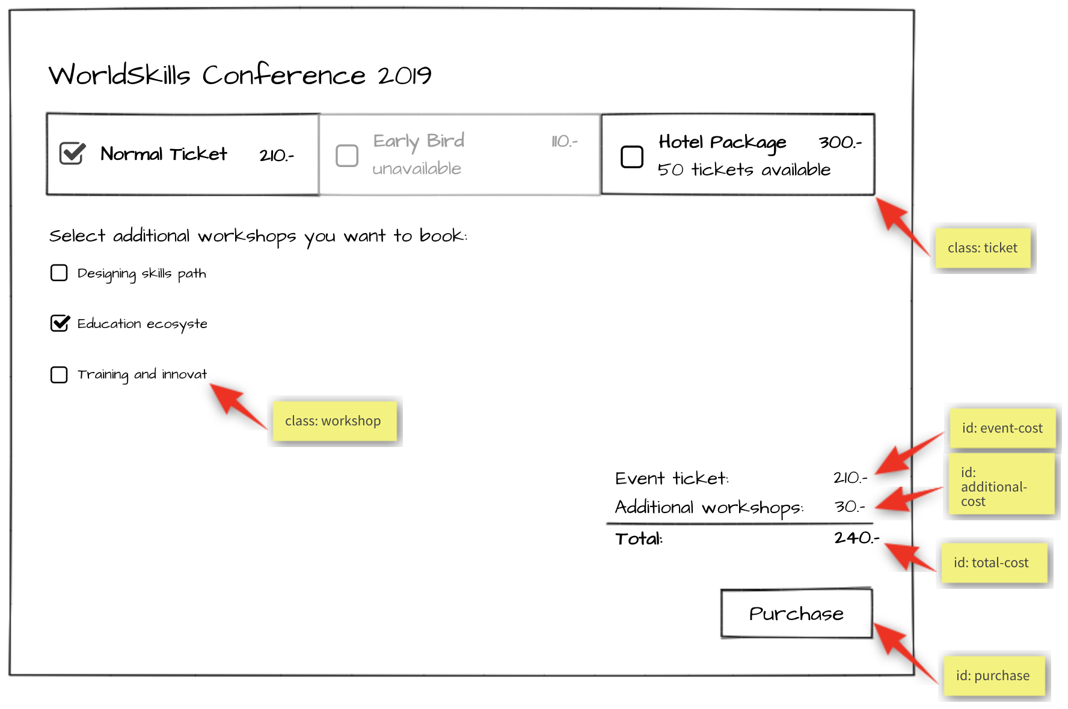

**Specification:**

*Feature*: C4 - Register for event: As an attendee, I want to be able to register for an event and pay the admission fee.

*Scenario*: C4a - Enter registration mode

*Given* I am on an event detail page

*And* I am logged in

*Then* I can click on a button to enter registration mode

*And* I see the ticket types and their cost

*And* I see a checkbox list of sessions of type workshop

*And* I see a cost view summary

*And* I see a disabled "Purchase" button

*Scenario*: C4b - Select ticket success

*Given* I am in registration mode of an event

*When* I select a ticket that is available

*Then* the ticket cost is displayed in the cost view summary

*And* the "Purchase" button is enabled

*Scenario*: C4c - Select ticket fail

*Given* I am in registration mode of an event

*When* I select a ticket that is not available

*Then* the ticket is not selected

*And* the "Purchase" button is not enabled

*Scenario*: C4d - Select workshop session

*Given* I am in registration mode in an event

*When* I tick a workshop session

*Then* the session receives a tick

*And* the price of the workshop is displayed under "Additional workshops" in

in the cost view

*And* the price of the session is added to the total cost

*Scenario*: C4e - Purchase

*Given* I am in registration mode in an event

*When* I select a ticket and I press the "Purchase” button

*Then* the registration is saved

*And* I get redirected to the event agenda

*And* a message appears "Registration successful"

### Attendee login

When registering for an event, a login is required. After a successful login, the login button in the navigation should no longer be visible. Instead, the username of the currently logged in user should be displayed and a button to log out.

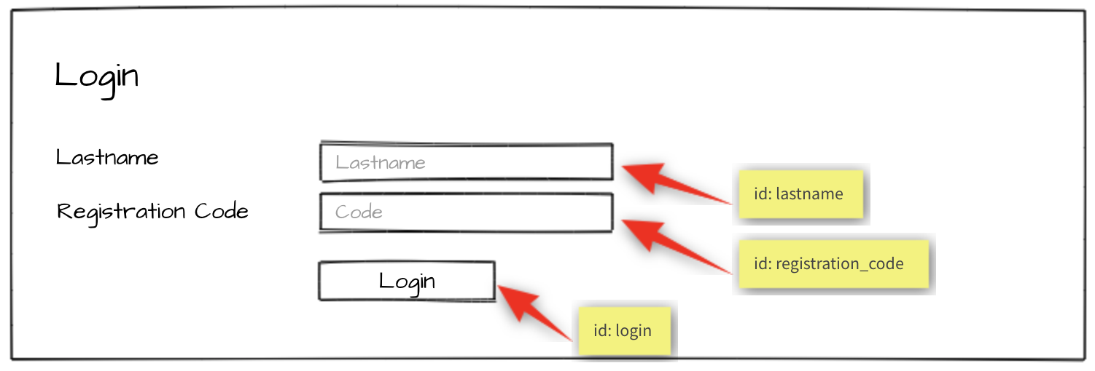

**Specification:**

*Feature*: C5 – Log in and log out as an attendee: As an attendee, I would like to log in and log out to the event

platform so that I can access my registrations and register for new events.

*Scenario*: C5a - Attendee login ok

*Given* I am on the "login" page

*When* I enter the specified lastname and registration code for an attendee

*And* press the "Login" button

*Then* I'm forwarded to the previous page

*And* username and "Logout" button become visible in the header

*Scenario*: C5b - Attendee login fail

*Given* I am on the "login" page

*When* I enter a wrong lastname and registration code for an attendee

*And* press the "Login" button

*Then* I stay on the "login" page

*And* I see an error message "Lastname or registration code not correct"

*Scenario*: C5c - Attendee logout

*Given* I am logged in

*When* I press the "Logout" button

*Then* I am forwarded to the "login" page

*And* username and logout button disappear

*And* I cannot reach the previous page by going back

# Notes

* When you are done with the first phase resp. after lunch you may continue with the second phase.
* If you are done with part one before the lunch break, you can start with part two by using your own API and exchange it at the start of the afternoon with the provided API.
* Competitors must use one of the server-side and client-side frameworks/libraries that are provided.
* The provided template for the admin interface should be used. It can be enhanced to get better functionality for your site. The visual design of the *admin interface* will *not* be assessed.
* The design of the attendee interface can be based on the template of the admin interface. The visual design of the attendee interface *will* be assessed: a simple, clean and attractive design is expected, including choice of colors, typography and spacing.  
  The design should be optimized for a minium window width of 1024px.
* For the admin interface it is important to use the selectors (class, id) as provided in the template. For the attendee interface it is important to use the selectors (class, id) as specified in the screen mockup (yellow bubbles).
* The specified database tables need to be implemented as provided. More tables may be added if needed. The given tables must not be changed. Provide a final SQL-dump and ERD screen as specified below.
* The API implementation should fulfill all requirements as stated in the description. All prefixes, RESTful-URLs and HTTP-Methods from the given API links must be implemented correctly and cannot be changed.
* Changes made in the data need to be propagated between frontend and backend in both directions.
* Update the first two organizers in the provided dump so it is possible to login to the system during assessment:
  + Organizer accounts:
    - Email: demo1@worldskills.org Password: demopass1
    - Email: demo2@worldskills.org Password: demopass2
* For the room capacity bar chart, you can use one of the provided JS-libraries (Charts.js, D3.js)

# Submission Instructions to the Competitor

Morning: Files to be collected after the first phase on the server:

* Web service (http://<hostname>/XX_JS-PHP_A/api/v1/..)
* Admin area (http://<hostname>/XX_JS-PHP_A/) - initially shows login page
* Folder inside webroot (XX_JS-PHP_A/)
* ERD screenshot named “XX_ERD.png” in “db-dump” folder inside of XX_JS-PHP_A
* Database dump named “XX_database.sql” in “db-dump” folder inside of XX_JS-PHP_A

Afternoon: Files to be collected after the second phase on the server:

* Front-end website (http://<hostname>/XX_JS-PHP_B/)
* Folder inside webroot (XX_JS-PHP_B/) - put all development files into XX_JS-PHP_B_dev.zip and leave only files for production-use in this directory.
* If the front-end root (http://<hostname>/XX_JS-PHP_B) does not open the main page directly, have it open an index.html with a link to the main page for marking your front-end.

XX is your country code

The Web Service / REST-API will be assessed with the **automated test-framework** provided. Additional data may be used to test dynamic behavior.

It is recommended that you run the automated tests for the REST-API after implementing it locally or at least after uploading it to the server. Instructions to setup and use the tests for the API: see README.md in tests_api-php.

Manual assessment of other parts will be done using **Google Chrome.**

# Equipment, machinery, installations, and materials required

It is expected that all Test Projects can be accomplished by Competitors based on the equipment and materials specified in the Infrastructure List*.

If any equipment or material is required that is not listed in the Infrastructure List, then it has to be listed here (in the table below - column headings may vary from skill to skill.)

WorldSkills International needs to approve any additional infrastructure requirements that are not listed in the Infrastructure List. Column headings may vary from skill to skill.

* (Definition: the Infrastructure List is the equipment, machinery, installations and materials supplied by the host country – it does not include tools and material to be supplied by Competitors and/or Experts)

|  |  |
| --- | --- |
| ITEM | description |
| Media Files | Contains: - DB dump  - Template files for the admin-gui  - Charts.js & D3.js incl. Documentation - Files for testing REST-API |

# Marking Scheme

|  |  |  |  |  |
| --- | --- | --- | --- | --- |
| SECTION | CRITERION | JUDG. MARKS | MEAS. MARKS | TOTAL |
| C1 | Database | 1.75 | 1.5 | 3.25 |
| C2 | Admin Backend | 0 | 3.25 | 3.25 |
| C3 | Ticket and Session | 0 | 1.5 | 1.5 |
| C4 | Organizer | 1 | 2.25 | 3.25 |
| C5 | REST API | 1.5 | 2.25 | 3.75 |
| D1 | Events list and agenda | 0 | 3.75 | 3.75 |
| D2 | Session and Events | 0 | 3 | 3 |
| D3 | General | 1 | 3 | 4 |
| D4 | JS Quality | 2.5 | 0 | 2.5 |
| D5 | Front end design | 3 | 0 | 3 |
| TOTAL |  | 10.75 | 20.5 | 31.25 |